Wirelesss communications assignment 2 : data dump
5G Physical layer info:
- 2 frequency ranges: sub-6GHz and mm-wave (higher freq.)
  - 100MHz BW for sub-6Ghz, 400MHz for mm-wave
  - Variable subcarrier spacing (see OFDM), but can only use 15, 30kHz spacing for sub-6, 120kHz for mmwave and 60 is common. Always a power-of-2 of 15kHz between 15 and 480kHz. Max 3300 subcarriers

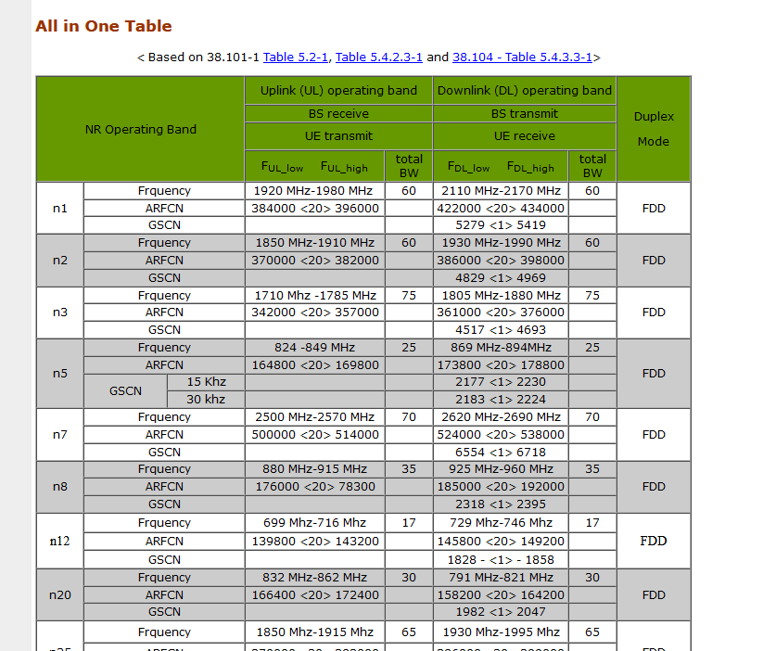
- See table on sharenote doc

Note: subcarriers: due to frequency spectrum fragmentation, the available spectrum is divided into 100MHz Carrier Components which are aggregated together to form a high bandwidth block (20MHz per CC for 4G/LTE, 100-400MHz for 5G). 5G allows for up to 16CCs to be aggregated.
5G seems to require linked OFDM symbols to be transmitted within 0.5ms of each other

Issues: 5G uses OFDM with spacing of a few dozen kHz in some cases. How close can two adjacent channels get without interference?
OFDM subcarrier orthonogality

